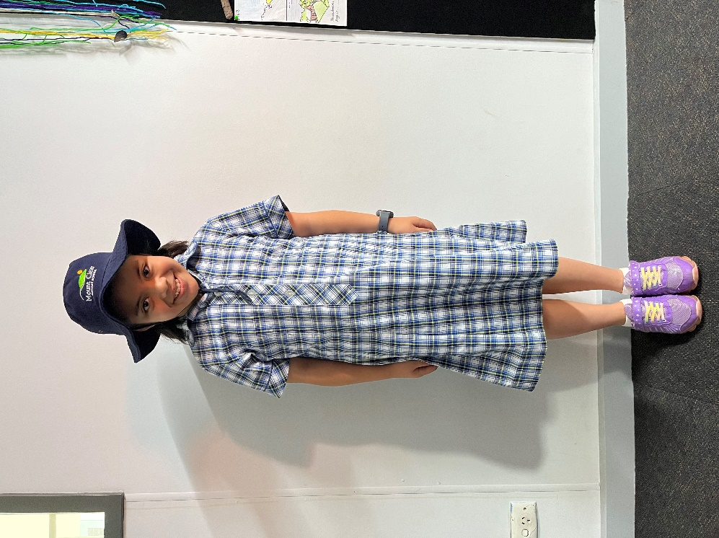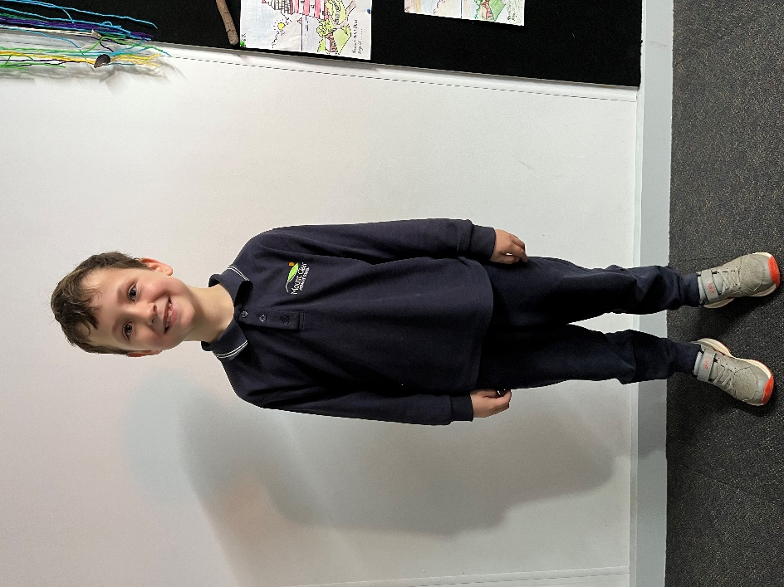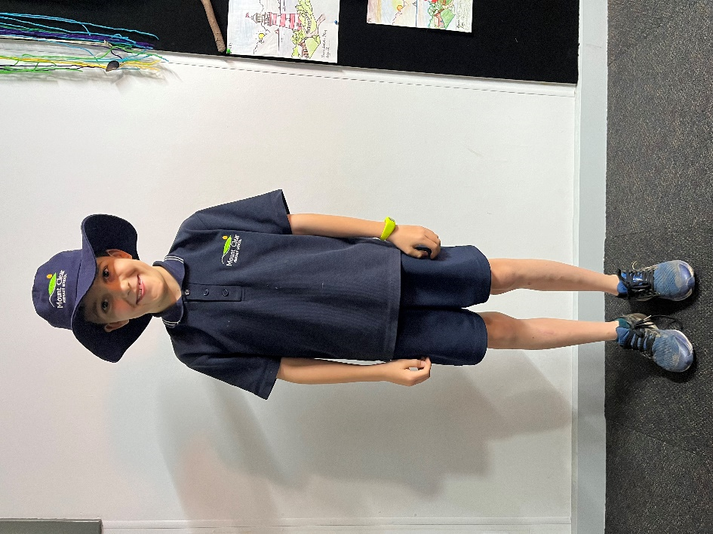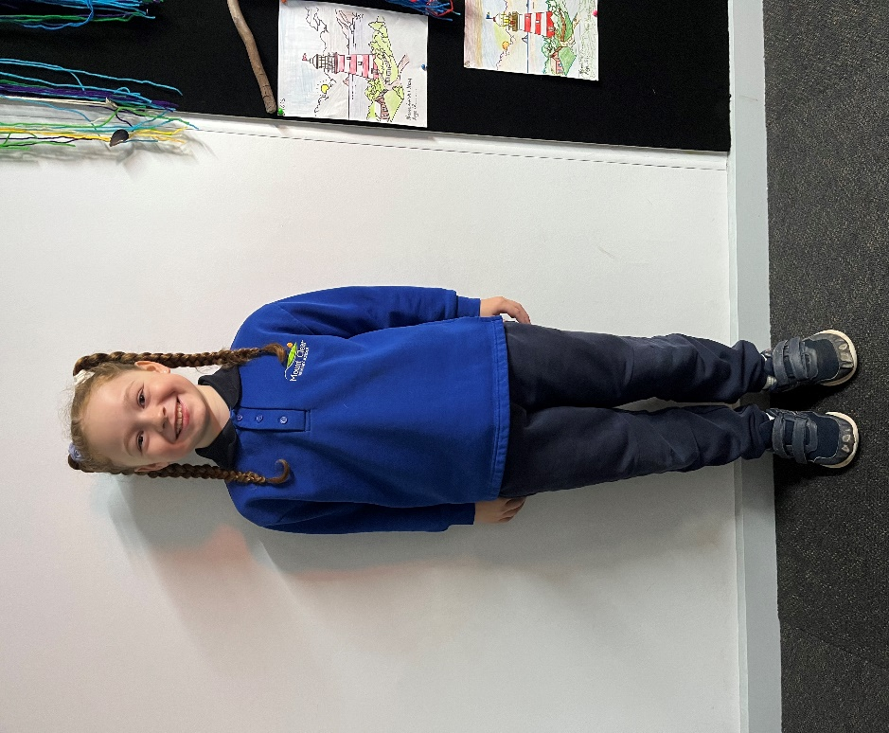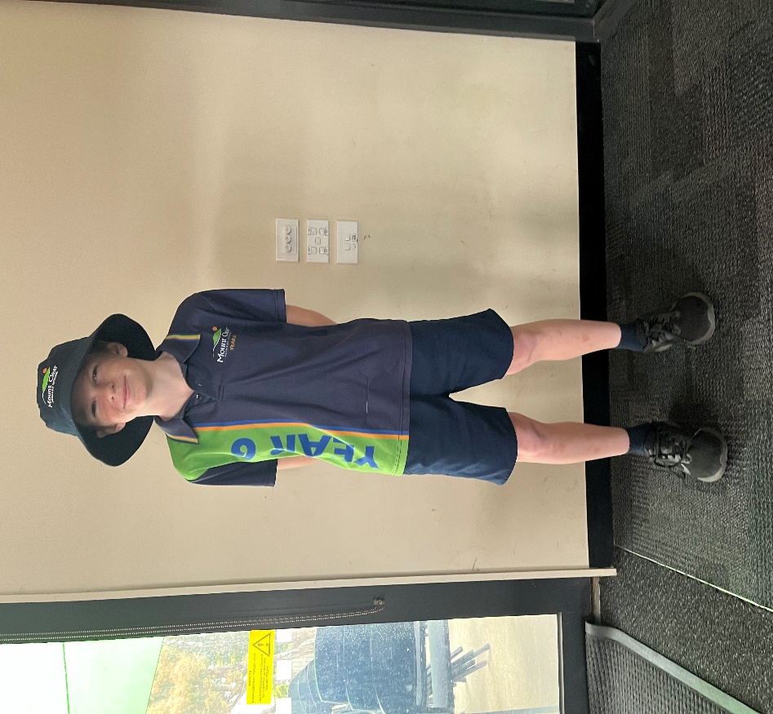**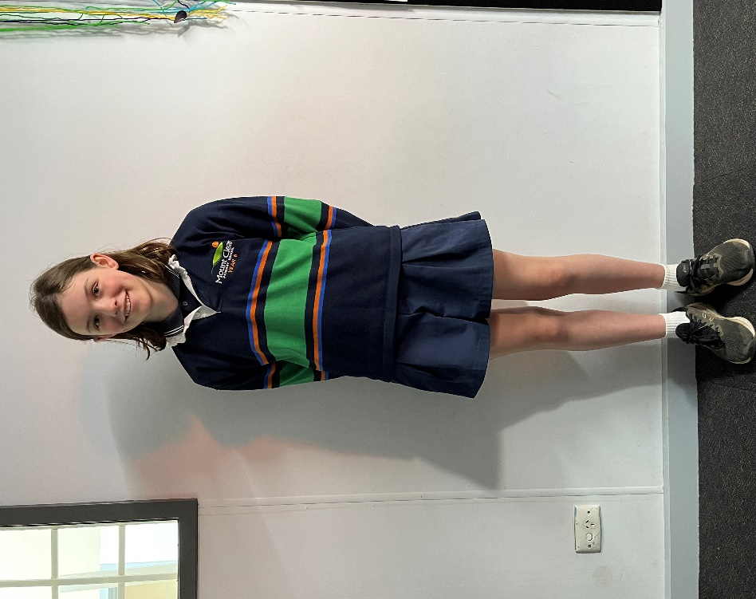Mount Clear Primary School Uniform**

**Girl’s summer dress Broad brimmed hat**

**Long sleeve polo Track pants**

**Year 6 rugby top Culottes**

**Year 6 polo Shorts Bucket hat**

**Fleecy jumper Track pants**

**Short sleeve polo Shorts Broad brimmed hat**

**Year 6 Uniform**

**Winter Uniform**

**Summer Uniform**